Management System for Boarding House

Problem Statement
Boarding House currently relies on manual methods to manage its daily operations. This reliance on paper-based records and spreadsheets has resulted in several operational inefficiencies, including:
Difficulty in accurately tracking payment histories, leading to uncollected arrears.
Delays in addressing maintenance requests due to poor communication channels.
Inability to quickly determine room availability and occupancy rates.
The lack of a centralized digital system hinders the boarding house's ability to scale and provides a subpar experience for tenants.

Project Objectives
The primary goal of this project is to develop a centralized management system that streamlines operations. The specific objectives are:
To Automate: tenant registration and digitize profile management to prevent data loss.
To Implement: a robust payment tracking system that monitors due dates and generates billing history.
To Enable: real-time room inventory management to track availability and assignments.
To Provide: a digital ticketing system for tenants to submit and track maintenance requests.
To Generate: administrative reports regarding revenue, occupancy, and tenant status.

Target Users
Administrator
The owner or manager of Boarding House. Since there is no staff, the Administrator handles all system configurations, tenant registrations, payment processing, and maintenance oversight.
Tenant
The individuals renting rooms. They interact with the system to view their financial standing, request repairs.

System Scope
In-Scope:
User Management: Admin login and Tenant profile creation.
Room Management: Assigning rooms, updating room status (Occupied/Available/Under Maintenance).
Billing: Recording payments, calculating arrears, and viewing payment history.
Maintenance: Submission of tickets by tenants and status updates by the Admin.
Notifications: System alerts for due bills or status changes.

Out-of-Scope:
Online Payment Gateway: Actual money transfers will not be processed inside the app; the system only records that a manual payment (Cash/Transfer) occurred.
Public Marketing Site: The system is an internal tool for management and existing tenants, not a website for advertising to the public.

UML Diagram (Use Case Diagram)
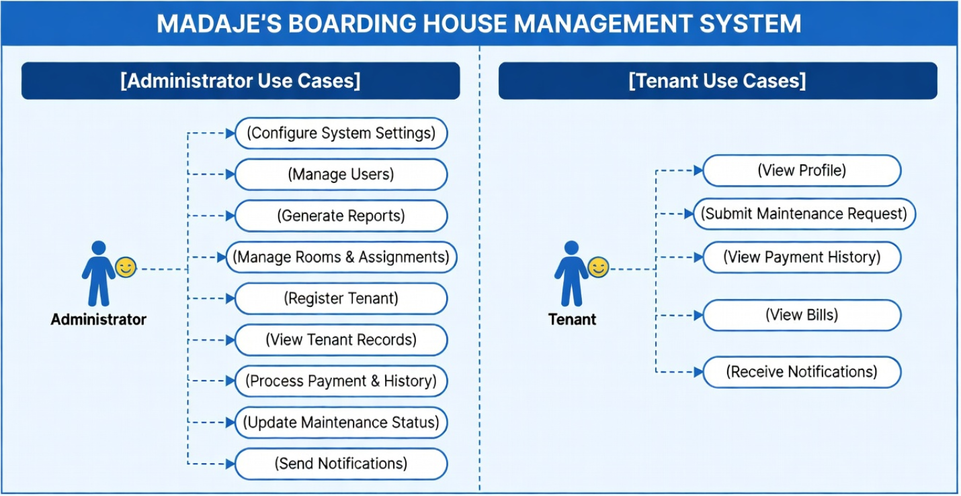

Diagram Description:
This Use Case diagram illustrates the interactions between the two actors (Administrator and Tenant) and the system. It highlights that the **Administrator** has taken over all operational duties (registering tenants, processing payments) previously held by staff.

